RESOLUTION NO.__________

RE: CERTIFICATE OF APPROPRIATENESS UNDER THE
PROVISIONS OF THE ACT OF THE PENNSYLVANIA
LEGISLATURE 1961, JUNE 13, P.L. 282 (53
SECTION 8004) AND BETHLEHEM ORDINANCE NO.
3952 AS AMENDED.

WHEREAS, it is proposed to install new snow guards on the roof at
545-547 Main St.

NOW, THEREFORE, BE IT RESOLVED by the Council of the City of Bethlehem that a Certificate of Appropriateness is hereby granted for the proposal.

Sponsored by: (s)

(s)

ADOPTED BY COUNCIL THIS DAY OF

(s)
President of Council

ATTEST:

(s)
City Clerk

HISTORICAL & ARCHITECTURAL REVIEW BOARD

APPLICATION #2: The applicant proposes to install new snow guards on the roof at
545-547 Main St.

OWNER: Anthony & Judy Krasnicke
4537 E. Valley Rd., Bethlehem, PA 18034
__________________________________________________________________

The Board upon motion by Phil Roeder and seconded by Beth Starbuck adopted the proposal that City Council issue a Certificate of Appropriateness for the following:

- Install a new snow guard consisting of two pipe guards.

2. Including stainless steel brackets and fasteners, located above existing metal
snow bird guards.

3. Install a copper base flashing and roof edge along the eave.

4. The motion was unanimously approved.

__________________________________________________________________________

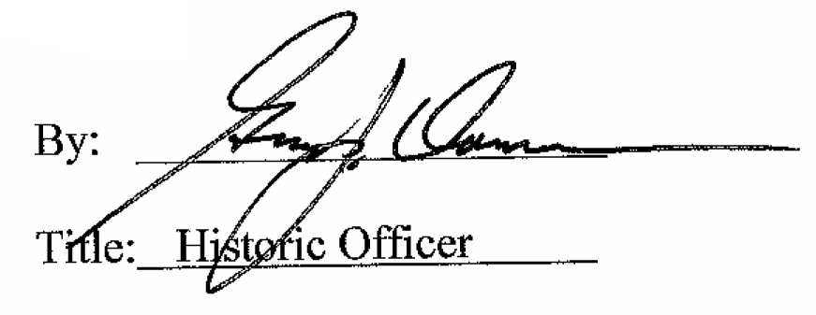

Date of Meeting: November 5, 2014

